# WEB DEVELOPMENT ASSIGNMENT 4

Adding committee member section and committee management interface also adding section to add success stories and to email them to member of committee and others

<!DOCTYPE html>

<html lang="en">

<head>

<meta charset="UTF-8">

<meta name="viewport" content="width=device-width, initial-scale=1.0">

<title>Aaroha</title>

<link rel="stylesheet" href="style assignment.css">

<style>

/* Basic Reset */

* {

margin: 0;

padding: 0;

box-sizing: border-box;

}

/* Body Styling */

body {

font-family: Arial, sans-serif;

background-color: #f8f9fa;

padding: 20px;

}

/* Header */

h1 {

text-align: center;

margin-bottom: 30px;

}

/* Section Styling */

section {

margin-bottom: 40px;

padding: 20px;

border-radius: 8px;

background-color: #fff;

box-shadow: 0 4px 8px rgba(0, 0, 0, 0.1);

}

/* Title in each Section */

h2 {

color: #333;

margin-bottom: 20px;

}

/* Form Container */

.form-container {

display: flex;

gap: 40px;

justify-content: space-between;

}

/* Form Group Styling */

.form-group {

flex: 1;

}

.form-group h3 {

margin-bottom: 15px;

font-size: 1.2em;

}

.form-group form {

display: flex;

flex-direction: column;

}

.form-group label {

margin-bottom: 5px;

font-weight: bold;

}

.form-group input,

.form-group select,

.form-group textarea {

padding: 8px;

margin-bottom: 15px;

border: 1px solid #ddd;

border-radius: 5px;

font-size: 1em;

}

.form-group button {

padding: 10px;

background-color: #007bff;

color: white;

border: none;

border-radius: 5px;

cursor: pointer;

font-size: 1em;

}

.form-group button:hover {

background-color: #0056b3;

}

/* Current Members List */

#committee-members-list {

list-style-type: none;

padding: 0;

}

#committee-members-list li {

padding: 15px;

background-color: #f4f4f4;

margin-bottom: 10px;

border-radius: 5px;

display: flex;

justify-content: space-between;

align-items: center;

}

#committee-members-list li button {

padding: 5px 10px;

background-color: #ff4d4d;

color: #fff;

border: none;

border-radius: 5px;

cursor: pointer;

}

#committee-members-list li button:hover {

background-color: #cc0000;

}

/* Success Stories Section */

#success-stories-section {

background-color: #e9ecef;

border-radius: 8px;

padding: 20px;

}

#add-story-form label {

margin-bottom: 10px;

}

#story-content {

resize: vertical;

}

#stories-display {

list-style-type: none;

margin-top: 20px;

}

#stories-display li {

margin-bottom: 15px;

padding: 10px;

background-color: #fff;

border-radius: 5px;

box-shadow: 0 2px 5px rgba(0, 0, 0, 0.1);

}

/* Buttons */

#email-stories-btn {

padding: 10px 20px;

background-color: #28a745;

color: white;

border: none;

border-radius: 5px;

font-size: 1.1em;

cursor: pointer;

}

#email-stories-btn:hover {

background-color: #218838;

}

/* Basic Reset */

* {

margin: 0;

padding: 0;

box-sizing: border-box;

}

/* Body Styling */

body {

font-family: Arial, sans-serif;

background-color: #f8f9fa;

padding: 20px;

}

/* Header */

h1 {

text-align: center;

margin-bottom: 30px;

}

/* Section Styling */

section {

margin-bottom: 40px;

padding: 20px;

border-radius: 8px;

background-color: #fff;

box-shadow: 0 4px 8px rgba(0, 0, 0, 0.1);

}

/* Success Stories Section */

#success-stories-section {

background-color: #e9ecef;

border-radius: 8px;

padding: 20px;

box-shadow: 0 4px 10px rgba(0, 0, 0, 0.1);

margin-bottom: 40px;

}

#add-story-form {

display: flex;

flex-direction: column;

gap: 15px;

margin-bottom: 20px;

}

#add-story-form label {

font-weight: bold;

margin-bottom: 5px;

}

#add-story-form input,

#add-story-form textarea,

#add-story-form button {

padding: 10px;

border-radius: 5px;

border: 1px solid #ccc;

font-size: 1em;

}

#add-story-form textarea {

resize: vertical;

min-height: 100px;

}

#add-story-form button {

background-color: #007bff;

color: white;

border: none;

cursor: pointer;

transition: background-color 0.3s;

}

#add-story-form button:hover {

background-color: #0056b3;

}

/* Displaying Stories */

#stories-display {

list-style-type: none;

padding: 0;

margin-top: 20px;

}

#stories-display li {

margin-bottom: 20px;

padding: 15px;

background-color: #fff;

border-radius: 8px;

box-shadow: 0 2px 8px rgba(0, 0, 0, 0.1);

}

#stories-display .story-title {

font-size: 1.2em;

font-weight: bold;

margin-bottom: 10px;

color: #007bff;

}

#stories-display .story-content {

margin-bottom: 10px;

font-size: 1em;

color: #333;

}

#stories-display .story-date {

font-size: 0.9em;

color: #777;

}

/* Buttons */

#email-stories-btn {

padding: 10px 20px;

background-color: #28a745;

color: white;

border: none;

border-radius: 5px;

font-size: 1.1em;

cursor: pointer;

margin-top: 20px;

}

#email-stories-btn:hover {

background-color: #218838;

}

/* Basic Reset */

* {

margin: 0;

padding: 0;

box-sizing: border-box;

}

/* Body Styling */

body {

font-family: Arial, sans-serif;

background-color: #f8f9fa;

padding: 20px;

}

/* Header */

h1 {

text-align: center;

margin-bottom: 30px;

}

/* Section Styling */

section {

margin-bottom: 40px;

padding: 20px;

border-radius: 8px;

background-color: #fff;

box-shadow: 0 4px 8px rgba(0, 0, 0, 0.1);

}

/* Title in each Section */

h2 {

color: #333;

margin-bottom: 20px;

}

/* Form Container */

.form-container {

display: flex;

gap: 40px;

justify-content: space-between;

}

/* Form Group Styling */

.form-group {

flex: 1;

}

.form-group h3 {

margin-bottom: 15px;

font-size: 1.2em;

}

.form-group form {

display: flex;

flex-direction: column;

}

.form-group label {

margin-bottom: 5px;

font-weight: bold;

}

.form-group input,

.form-group select,

.form-group textarea {

padding: 8px;

margin-bottom: 15px;

border: 1px solid #ddd;

border-radius: 5px;

font-size: 1em;

}

.form-group button {

padding: 10px;

background-color: #007bff;

color: white;

border: none;

border-radius: 5px;

cursor: pointer;

font-size: 1em;

}

.form-group button:hover {

background-color: #0056b3;

}

/* Current Members List */

#committee-members-list {

list-style-type: none;

padding: 0;

}

#committee-members-list li {

padding: 15px;

background-color: #f4f4f4;

margin-bottom: 10px;

border-radius: 5px;

display: flex;

justify-content: space-between;

align-items: center;

}

#committee-members-list li button {

padding: 5px 10px;

background-color: #ff4d4d;

color: #fff;

border: none;

border-radius: 5px;

cursor: pointer;

}

#committee-members-list li button:hover {

background-color: #cc0000;

}

/* Success Stories Section */

#success-stories-section {

background-color: #e9ecef;

border-radius: 8px;

padding: 20px;

}

#add-story-form label {

margin-bottom: 10px;

}

#story-content {

resize: vertical;

}

#stories-display {

list-style-type: none;

margin-top: 20px;

}

#stories-display li {

margin-bottom: 15px;

padding: 10px;

background-color: #fff;

border-radius: 5px;

box-shadow: 0 2px 5px rgba(0, 0, 0, 0.1);

}

/* Buttons */

#email-stories-btn {

padding: 10px 20px;

background-color: #28a745;

color: white;

border: none;

border-radius: 5px;

font-size: 1.1em;

cursor: pointer;

}

#email-stories-btn:hover {

background-color: #218838;

}

body {

font-family: 'Segoe UI', Tahoma, Geneva, Verdana, sans-serif;

margin: 0;

padding: 0;

background-color: #e8f0fe;

color: #333;

}

.container {

width: 90%;

margin: 40px auto;

padding: 20px;

background-color: #ffffff;

border-radius: 12px;

box-shadow: 0 4px 20px rgba(0, 0, 0, 0.15);

}

h1 {

text-align: center;

color: #444;

font-size: 2.5em;

margin-bottom: 30px;

}

.grid {

display: grid;

grid-template-columns: repeat(auto-fit, minmax(300px, 1fr));

gap: 30px;

}

.member {

display: flex;

flex-direction: column;

align-items: center;

padding: 20px;

border: none;

border-radius: 10px;

background: linear-gradient(145deg, #ffffff, #dce6f0);

box-shadow: 10px 10px 20px rgba(0, 0, 0, 0.05);

transition: transform 0.3s ease, box-shadow 0.3s ease;

}

.member:hover {

transform: translateY(-10px);

box-shadow: 0 8px 30px rgba(0, 0, 0, 0.1);

}

.member img {

border-radius: 50%;

width: 120px;

height: 120px;

margin-bottom: 15px;

object-fit: cover;

border: 4px solid #dee3e8;

}

.member-info {

text-align: center;

}

.member-info h3 {

margin: 10px 0 5px;

font-size: 1.5em;

color: #222;

}

.member-info p {

margin: 0;

font-size: 1em;

color: #555;

}

.social-links {

margin-top: 15px;

}

.social-links a {

margin: 0 8px;

text-decoration: none;

color: #555;

font-size: 22px;

transition: color 0.3s ease;

}

.social-links a:hover {

color: #007bff;

}

</style>

</head>

<body>

<header>

<div style="background-color: #0a0e49;">

<!-- <div style="position: absolute; top: 0; left: 0; width: 100%; height: 100%; z-index: -1;">

<iframe src="https://www.youtube.com/embed/wCKXOyffrGU?autoplay=1&mute=1&controls=0&showinfo=0&rel=0" frameborder="0" style="width: 100%; height: 100%; object-fit: cover;" allow="autoplay; encrypted-media" allowfullscreen></iframe>

</div> -->

<h1 style="color: #0000FF;">

<img src="62048091-logo-design-template-for-karaoke-vector-illustration-of-icon.jpg"

alt="This is club logo" width="200px" height="200px">

Welcome to the Aaroha Club

</h1>

<nav>

<a href="http://127.0.0.1:5500/web%20Development/Assignment%204/web%20page%20assignment.html">Home</a>

<a href="http://127.0.0.1:5500/web%20Development/Assignment%203/Web%20Developmet%20About%20us.html">About Us</a>

<a href="http://127.0.0.1:5500/web%20Development/Assignment%203/Web%20Development%20assignmenet%20events.html">Events</a>

<a href="#join">Join Us</a>

<a href="#contact">Contact</a>

<a href="http://127.0.0.1:5500/web%20Development/Assignment%204/comittie%20member.html">Committee</a>

</nav>

</div>

</header>

<div class="container">

<div class="content">

<h1 id="header1">Commity of Tune Troopers</h1>

</div>

<div class="container">

<h1>Committee Members</h1>

<div class="grid">

<div class="member">

<img src="member1.jpg" alt="">

<div class="member-info">

<h3 id="first"></h3>

<p>Chairperson</p>

</div>

<div class="social-links">

<a href="#" title="LinkedIn">&#128279;</a>

<a href="#" title="Twitter">&#128081;</a>

<a href="#" title="Email">&#9993;</a>

</div>

</div>

<div class="member">

<img src="member2.jpg" alt="Jane Smith">

<div class="member-info">

<h3>Jane Smith</h3>

<p>Vice Chairperson</p>

</div>

<div class="social-links">

<a href="#" title="LinkedIn">&#128279;</a>

<a href="#" title="Twitter">&#128081;</a>

<a href="#" title="Email">&#9993;</a>

</div>

</div>

<div class="member">

<img src="member3.jpg" alt="Emily Johnson">

<div class="member-info">

<h3>Emily Johnson</h3>

<p>Secretary</p>

</div>

<div class="social-links">

<a href="#" title="LinkedIn">&#128279;</a>

<a href="#" title="Twitter">&#128081;</a>

<a href="#" title="Email">&#9993;</a>

</div>

</div>

<div class="member">

<img src="member4.jpg" alt="Michael Brown">

<div class="member-info">

<h3>Michael Brown</h3>

<p>Treasurer</p>

</div>

<div class="social-links">

<a href="#" title="LinkedIn">&#128279;</a>

<a href="#" title="Twitter">&#128081;</a>

<a href="#" title="Email">&#9993;</a>

</div>

</div>

</div>

</div>

<h1>Club Management Interface</h1>

<!-- Update Club Committee Section -->

<section id="update-committee-section">

<h2>Update Club Committee</h2>

<div class="form-container">

<!-- Add New Member Section -->

<!-- Add New Member Section -->

<div class="form-group">

<h3>Add New Member</h3>

<form id="add-member-form">

<label for="new-name">Name:</label>

<input type="text" id="new-name" placeholder="Enter member name" required>

<label for="new-member-role">Role:</label>

<input type="text" id="new-member-role" placeholder="Enter member role" required>

<label for="new-branch">Branch:</label>

<input type="text" id="new-branch" placeholder="Enter member branch" required>

<label for="new-department">Department:</label>

<input type="text" id="new-department" placeholder="Enter member department" required>

<label for="new-phone">Phone Number:</label>

<input type="tel" id="new-phone" placeholder="Enter phone number" required>

<label for="new-email">Email:</label>

<input type="email" id="new-email" placeholder="Enter member email" required>

<label for="new-image">Profile Picture:</label>

<input type="file" id="new-image" accept="image/*">

<button type="button" id="add-member-btn">Add Member</button>

</form>

</div>

<!-- Update Member Section -->

<div class="form-group">

<h3>Update Member</h3>

<form id="update-committee-form">

<label for="member-selector">Select Member:</label>

<select id="member-selector"></select>

<label for="update-name">New Name:</label>

<input type="text" id="update-name" placeholder="Enter new name" required>

<label for="new-role">New Role:</label>

<input type="text" id="new-role" placeholder="Enter new role" required>

<label for="new-branch">New Branch:</label>

<input type="text" id="new-branch" placeholder="Enter new branch" required>

<label for="new-department">New Department:</label>

<input type="text" id="new-department" placeholder="Enter new department" required>

<label for="new-phone">New Phone Number:</label>

<input type="tel" id="new-phone" placeholder="Enter new phone number" required>

<label for="new-email">New Email:</label>

<input type="email" id="new-email" placeholder="Enter new email" required>

<label for="update-image">New Profile Picture:</label>

<input type="file" id="update-image" accept="image/*">

<button type="button" id="update-member-btn">Update Member</button>

</form>

</div>

</div>

</section>

<!-- Section to manage success stories -->

<section id="success-stories-section">

<h2>Manage Success Stories</h2>

<form id="add-story-form">

<label for="story-title">Story Title:</label>

<input type="text" id="story-title" placeholder="Enter story title" required>

<label for="story-content">Story Content:</label>

<textarea id="story-content" placeholder="Write the success story..." required></textarea>

<button type="button" id="add-story-btn">Add Story</button>

</form>

<div id="stories-list">

<h3>Current Success Stories</h3>

<ul id="stories-display"></ul>

</div>

<button type="button" id="email-stories-btn">Email Success Stories</button>

</section>

</div>

<div class="ending">

<div class="content" id="join">

<h3>Join Us</h3>

<p>If you love singing and want to improve your skills, we invite you to join our club! Fill out the <a

href="http://127.0.0.1:5500/web%20Development/Assignment%203/Contact%20Frorm.html">contact form</a>

below to get started.</p>

</div>

<div class="content" id="contact">

<h3>Contact Us</h3>

<ul>

<li>

<p>If you have any questions or would like more information, please reach out!</p>

</li>

<li>

<p>Email: <a href="mailto:info@aaroha.com">info@singingclub.com</a></p>

</li>

<li>

<p>Insta: <a href="https://www.instagram.com/vit_aaroh/" target="_blank"> Aaroha(vit pune)</a></p>

</li>

</ul>

</div>

</div>

<footer>

<p>&copy; 2024 Singing Club. All rights reserved. || validated by RK</p>

</footer>

<script src="script.js"></script>

</body>

</html>

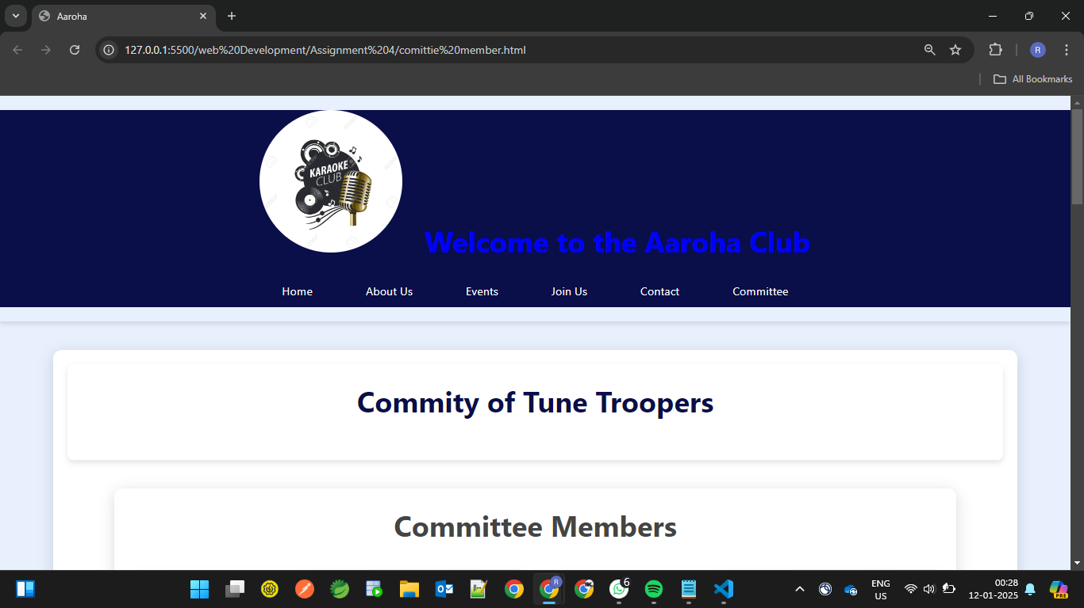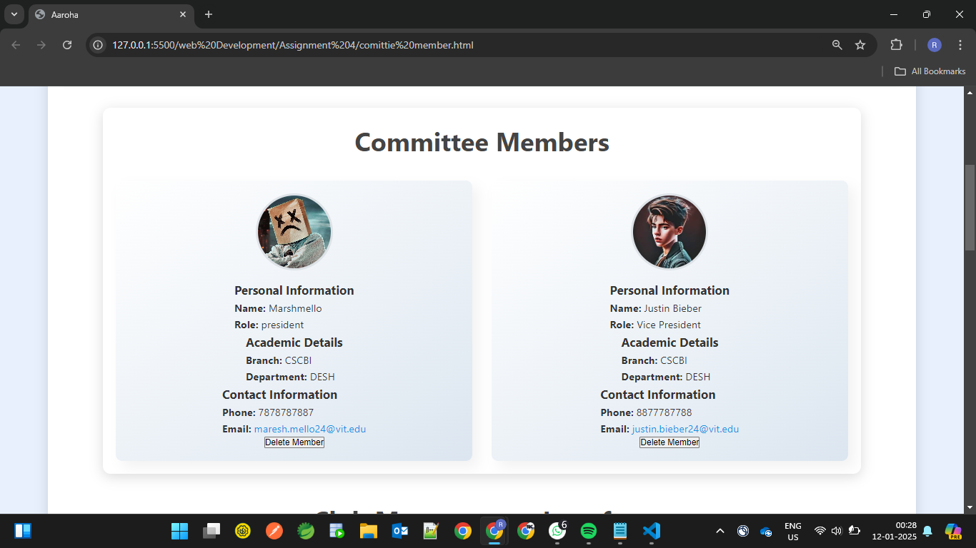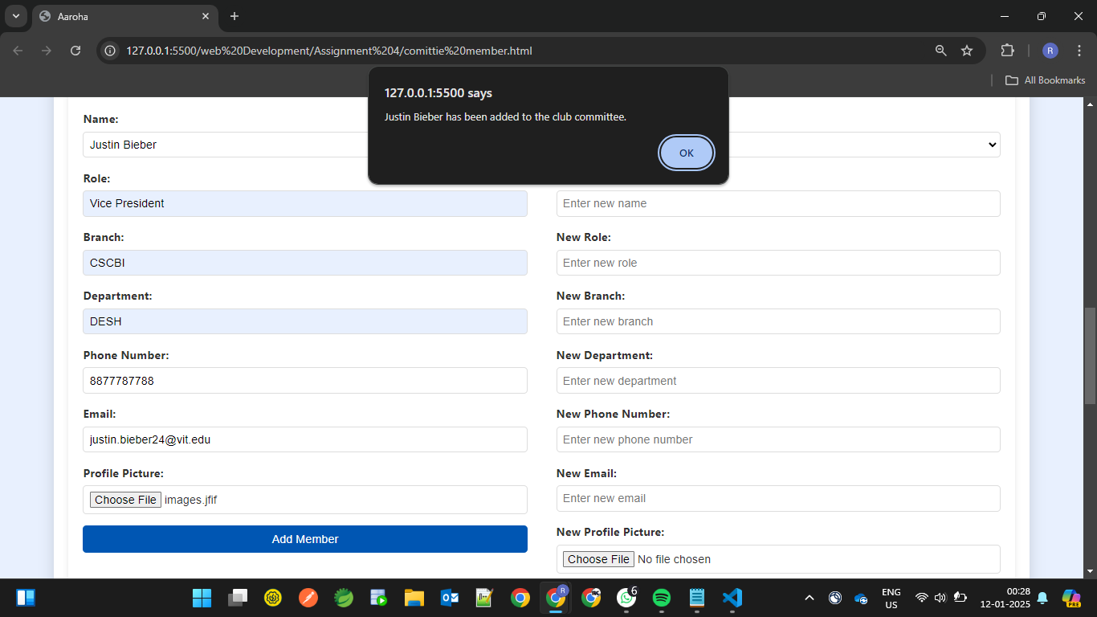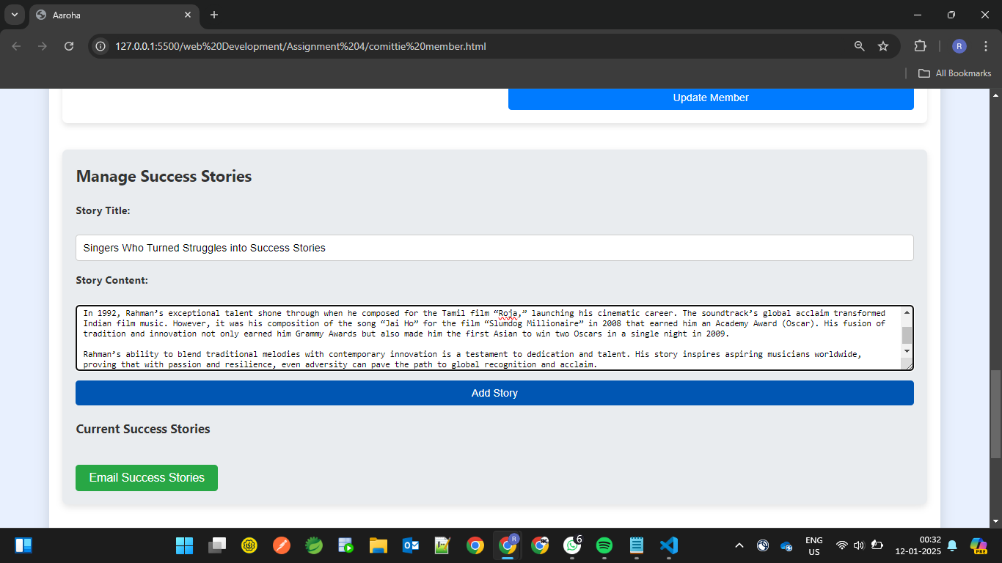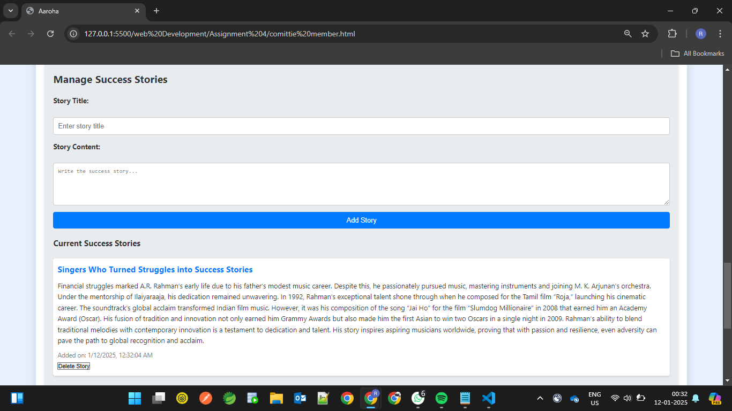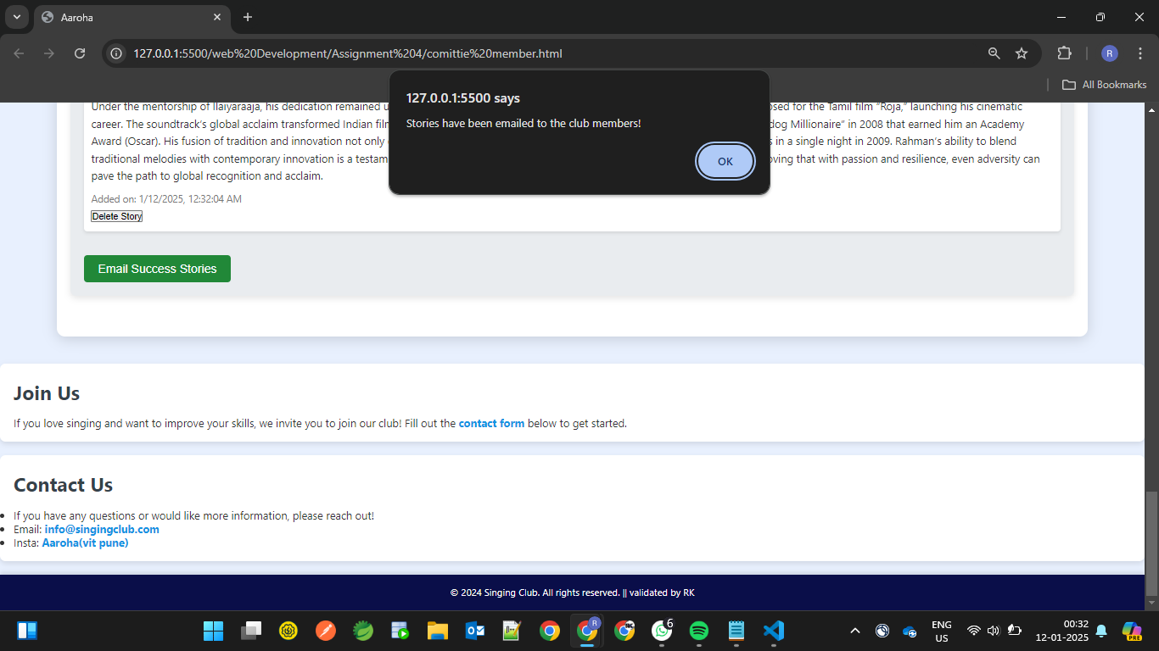

# JAVASCRIPT FOR THE ASSIGNMENT

// Initialize an array to store members

let committeeMembers = JSON.parse(localStorage.getItem("committeeMembers")) || [];

// Function to save committeeMembers to local storage

function saveMembersToLocalStorage() {

localStorage.setItem("committeeMembers", JSON.stringify(committeeMembers));

}

// Function to render members in the grid

function renderMembers() {

const memberGrid = document.querySelector(".grid");

memberGrid.innerHTML = ""; // Clear existing members

committeeMembers.forEach((member, index) => {

const memberCard = `

<div class="member" data-index="${index}">

<img src="${member.image || 'default-avatar.jpg'}" alt="${member.name}" />

<!-- Personal Information Section -->

<div class="member-info-section">

<h3>Personal Information</h3>

<p><strong>Name:</strong> ${member.name}</p>

<p><strong>Role:</strong> ${member.role}</p>

</div>

<!-- Academic Details Section -->

<div class="member-info-section">

<h3>Academic Details</h3>

<p><strong>Branch:</strong> ${member.branch}</p>

<p><strong>Department:</strong> ${member.department}</p>

</div>

<!-- Contact Information Section -->

<div class="member-info-section">

<h3>Contact Information</h3>

<p><strong>Phone:</strong> ${member.phone}</p>

<p><strong>Email:</strong> <a href="mailto:${member.email}">${member.email}</a></p>

</div>

<!-- Delete Button -->

<button class="delete-member-btn">Delete Member</button>

</div>

`;

memberGrid.insertAdjacentHTML("beforeend", memberCard);

});

// Attach event listeners to all delete buttons

document.querySelectorAll(".delete-member-btn").forEach((button, index) => {

button.addEventListener("click", function () {

deleteMember(index);

});

});

}

// Function to populate the "Select Member" dropdown

function populateMemberSelector() {

const memberSelector = document.getElementById("member-selector");

memberSelector.innerHTML = ""; // Clear existing options

committeeMembers.forEach((member, index) => {

const option = document.createElement("option");

option.value = index;

option.textContent = member.name;

memberSelector.appendChild(option);

});

}

// Function to handle member selection and pre-fill the form

document.getElementById("member-selector").addEventListener("change", function () {

const selectedIndex = this.value;

if (selectedIndex === "") return;

const selectedMember = committeeMembers[selectedIndex];

// Pre-fill the form fields with the selected member's details

document.getElementById("update-name").value = selectedMember.name;

document.getElementById("new-role").value = selectedMember.role;

document.getElementById("new-branch").value = selectedMember.branch;

document.getElementById("new-department").value = selectedMember.department;

document.getElementById("new-phone").value = selectedMember.phone;

document.getElementById("new-email").value = selectedMember.email;

});

// Handle Update Member Button Click

document.getElementById("update-member-btn").addEventListener("click", function () {

const selectedIndex = document.getElementById("member-selector").value;

if (selectedIndex === "") {

alert("Please select a member to update.");

return;

}

const updatedName = document.getElementById("update-name").value.trim();

const updatedRole = document.getElementById("new-role").value.trim();

const updatedBranch = document.getElementById("new-branch").value.trim();

const updatedDepartment = document.getElementById("new-department").value.trim();

const updatedPhone = document.getElementById("new-phone").value.trim();

const updatedEmail = document.getElementById("new-email").value.trim();

const updateImageInput = document.getElementById("update-image");

// Validate inputs

if (!validateName(updatedName)) {

alert("Please enter a valid name (letters and spaces only).");

return;

}

if (updatedRole === "") {

alert("Role cannot be empty.");

return;

}

if (updatedBranch === "") {

alert("Branch cannot be empty.");

return;

}

if (updatedDepartment === "") {

alert("Department cannot be empty.");

return;

}

if (!validatePhone(updatedPhone)) {

alert("Please enter a valid 10-digit phone number.");

return;

}

if (!validateEmail(updatedEmail)) {

alert("Please enter a valid email address.");

return;

}

if (updateImageInput.files.length > 0 && !validateImage(updateImageInput.files[0])) {

alert("Please upload a valid image (JPEG or PNG).");

return;

}

// Check if a new image file is selected and read it using FileReader

if (updateImageInput.files && updateImageInput.files[0]) {

const reader = new FileReader();

reader.onload = function (e) {

const updatedImage = e.target.result; // Base64 string of the image

updateMemberDetails(selectedIndex, updatedName, updatedRole, updatedBranch, updatedDepartment, updatedPhone, updatedEmail, updatedImage);

};

reader.readAsDataURL(updateImageInput.files[0]); // Read image file as data URL

} else {

// If no new image is selected, keep the existing image

const existingImage = committeeMembers[selectedIndex].image || "default-avatar.jpg";

updateMemberDetails(selectedIndex, updatedName, updatedRole, updatedBranch, updatedDepartment, updatedPhone, updatedEmail, existingImage);

}

});

// Function to update member details

function updateMemberDetails(index, name, role, branch, department, phone, email, image) {

// Update the selected member's details in the array

committeeMembers[index] = { name, role, branch, department, phone, email, image };

// Save updated members list to local storage

saveMembersToLocalStorage();

// Re-render members and update the selector

renderMembers();

populateMemberSelector();

// Reset the form fields

document.getElementById("update-committee-form").reset();

alert("Member details have been updated.");

}

// Function to validate name (letters and spaces only)

function validateName(name) {

const namePattern = /^[A-Za-z\s]+$/;

return namePattern.test(name);

}

// Function to validate phone number (10 digits)

function validatePhone(phone) {

const phonePattern = /^\d{10}$/;

return phonePattern.test(phone);

}

// Function to validate email

function validateEmail(email) {

const emailPattern = /^[^\s@]+@[^\s@]+\.[^\s@]+$/;

return emailPattern.test(email);

}

// Function to validate image file type (JPEG or PNG)

function validateImage(file) {

const allowedTypes = ["image/jpeg", "image/png"];

return allowedTypes.includes(file.type);

}

// Function to delete a member

function deleteMember(index) {

if (confirm(`Are you sure you want to delete ${committeeMembers[index].name}?`)) {

// Remove member from the array

committeeMembers.splice(index, 1);

// Save updated members list to local storage

saveMembersToLocalStorage();

// Re-render members and update the selector

renderMembers();

populateMemberSelector();

alert("Member has been deleted.");

}

}

// Add New Member

document.getElementById("add-member-btn").addEventListener("click", function () {

const newName = document.getElementById("new-name").value.trim();

const newRole = document.getElementById("new-member-role").value.trim();

const newBranch = document.getElementById("new-branch").value.trim();

const newDepartment = document.getElementById("new-department").value.trim();

const newPhone = document.getElementById("new-phone").value.trim();

const newEmail = document.getElementById("new-email").value.trim();

const newImageInput = document.getElementById("new-image");

// Validate inputs

if (!validateName(newName)) {

alert("Please enter a valid name (letters and spaces only).");

return;

}

if (newRole === "") {

alert("Role cannot be empty.");

return;

}

if (newBranch === "") {

alert("Branch cannot be empty.");

return;

}

if (newDepartment === "") {

alert("Department cannot be empty.");

return;

}

if (!validatePhone(newPhone)) {

alert("Please enter a valid 10-digit phone number.");

return;

}

if (!validateEmail(newEmail)) {

alert("Please enter a valid email address.");

return;

}

if (newImageInput.files.length > 0 && !validateImage(newImageInput.files[0])) {

alert("Please upload a valid image (JPEG or PNG).");

return;

}

// Check if an image file is selected and read it using FileReader

let newImage = "";

if (newImageInput.files && newImageInput.files[0]) {

const reader = new FileReader();

reader.onload = function (e) {

newImage = e.target.result; // Base64 string of the image

addMember(newName, newRole, newBranch, newDepartment, newPhone, newEmail, newImage);

};

reader.readAsDataURL(newImageInput.files[0]); // Read image file as data URL

} else {

addMember(newName, newRole, newBranch, newDepartment, newPhone, newEmail, newImage);

}

});

// Function to add a new member

function addMember(name, role, branch, department, phone, email, image) {

const newMember = { name, role, branch, department, phone, email, image };

committeeMembers.push(newMember);

saveMembersToLocalStorage();

renderMembers();

populateMemberSelector();

document.getElementById("add-member-form").reset();

alert(`${name} has been added to the club committee.`);

}

// Function to validate name (letters and spaces only)

function validateName(name) {

const namePattern = /^[A-Za-z\s]+$/;

return namePattern.test(name);

}

// Function to validate phone number (10 digits)

function validatePhone(phone) {

const phonePattern = /^\d{10}$/;

return phonePattern.test(phone);

}

// Function to validate email

function validateEmail(email) {

const emailPattern = /^[^\s@]+@[^\s@]+\.[^\s@]+$/;

return emailPattern.test(email);

}

// Function to validate image file type (JPEG or PNG)

function validateImage(file) {

const allowedTypes = ["image/jpeg", "image/png"];

return allowedTypes.includes(file.type);

}

// Function to handle member selection and pre-fill the form

document.getElementById("member-selector").addEventListener("change", function () {

const selectedIndex = this.value;

if (selectedIndex === "") return;

const selectedMember = committeeMembers[selectedIndex];

document.getElementById("update-name").value = selectedMember.name;

document.getElementById("new-role").value = selectedMember.role;

document.getElementById("new-branch").value = selectedMember.branch;

document.getElementById("new-department").value = selectedMember.department;

document.getElementById("new-phone").value = selectedMember.phone;

document.getElementById("new-email").value = selectedMember.email;

});

// Function to update member details

function updateMemberDetails(index, name, role, branch, department, phone, email, image) {

committeeMembers[index] = { name, role, branch, department, phone, email, image };

saveMembersToLocalStorage();

renderMembers();

populateMemberSelector();

alert("Member details have been updated.");

}

// Array to store stories

let stories = [];

// Function to render stories

function renderStories() {

const storiesDisplay = document.getElementById("stories-display");

storiesDisplay.innerHTML = ""; // Clear existing stories

stories.forEach((story, index) => {

const storyItem = `

<li data-index="${index}">

<div class="story-title">${story.title}</div>

<div class="story-content">${story.content}</div>

<div class="story-date">Added on: ${story.date}</div>

<button class="delete-story-btn">Delete Story</button>

</li>

`;

storiesDisplay.insertAdjacentHTML("beforeend", storyItem);

});

// Attach event listeners to all delete buttons

document.querySelectorAll(".delete-story-btn").forEach((button, index) => {

button.addEventListener("click", function () {

deleteStory(index);

});

});

}

// Add a new success story

document.getElementById("add-story-btn").addEventListener("click", function () {

const storyTitle = document.getElementById("story-title").value.trim();

const storyContent = document.getElementById("story-content").value.trim();

if (storyTitle === "" || storyContent === "") {

alert("Please fill in both the story title and content.");

return;

}

const storyDate = new Date().toLocaleString(); // Get current date and time

// Create a new story object

const newStory = {

title: storyTitle,

content: storyContent,

date: storyDate

};

// Add the new story to the stories array

stories.push(newStory);

// Render stories again to update the list

renderStories();

// Clear the form fields

document.getElementById("story-title").value = "";

document.getElementById("story-content").value = "";

// Show an alert for successful story addition

alert("Story added successfully!");

});

// Function to delete a story

function deleteStory(index) {

if (confirm("Are you sure you want to delete this story?")) {

// Remove the story from the array

stories.splice(index, 1);

// Render stories again to update the list

renderStories();

alert("Story deleted successfully!");

}

}

// Email stories (dummy functionality)

document.getElementById("email-stories-btn").addEventListener("click", function () {

if (stories.length === 0) {

alert("No stories to email.");

return;

}

alert("Stories have been emailed to the club members!");

});

// Call renderMembers and populateMemberSelector on page load

renderMembers();

populateMemberSelector();